Created on: 1/21/05
Topic: Basic Patterns and Motions in the Sky

- Latitude – Angle North of South of the equator (+90º to –90º)
- Longitude – Angle around the Earth running from 180º East to 180º West (not parallel to one another)
- North and South (Terrestrial) Poles have undefined longitudes
- Terrestrial Equator – 0º latitude
- Horizon – boundary between Earth and sky (gigantic circle surrounding you)
- Celestial Sphere – Imaginary sphere that you are at the center at and everything in the Universe is “painted” on it
- Horizon Coordinates (on the Celestial Sphere):
  - Altitude – Angle above or below the horizon
    - Above: + (you can see it)
    - Middle: 0º (The horizon itself)
    - Below: – (you can’t see it)
  - Azimuth – Angle around the celestial sphere:
    - North: 0º/360º azimuth
    - East: 90º azimuth
    - South: 180º azimuth
    - West: 270º azimuth
      - These 4 direction can be labeled on the horizon as North, East, South, and West Points
  - Zenith: Altitude: +90º (undefined azimuth)
  - Nadir: Altitude: –90º (undefined azimuth)
- Professional astronomers almost never use horizon coordinates
- Horizon coordinates only apply to your current location
- Everything in the sky does not have a fixed set of horizon coordinates because the Earth is rotating
- The Sun (and everything else) rises in the East and sets in the West
- Meridian – A giant circle that starts at the North Point, goes through the Zenith, goes through the South Point, goes through the Nadir, and goes back to the North Point
- Rising – Crosses horizon at the East (0º altitude) – Example: Sunrise
- Culmination/Transiting – Crosses the meridian – Examples: Noon and Midnight
- Setting – Crosses horizon at the West (0º altitude) – Example: Sunset
- AM – Anti Meridian
- PM – Post Meridian
- We should not be using horizon coordinates
- Equatorial coordinates:
  - Right ascension – Like longitude on the Earth but on the Celestial Sphere (not parallel to one another) – Measured in hours – 15º is an hour
  - Declination – Like latitude on the Earth but on the Celestial Sphere
  - Celestial Equator – Equator on the Celestial Sphere (at 0º Declination)
- North Celestial Pole: Declination: +90º (undefined right ascension)
- South Celestial Pole: Declination: –90º (undefined right ascension)
- North and South Celestial Poles are located where the North and South Terrestrial Poles are located
- You can only find true North via the North Star (a compass only finds magnetic North)
- You can find out the latitude of your location (and the cardinal directions) via the altitude of the North Star
- Circumpolar stars – Stars that run around the North Star (and the South Star if there were one)
- Circumpolar constellations:
  - The Big Dipper – 7 stars (part of Ursa Major, “The Big Bear”, both below)
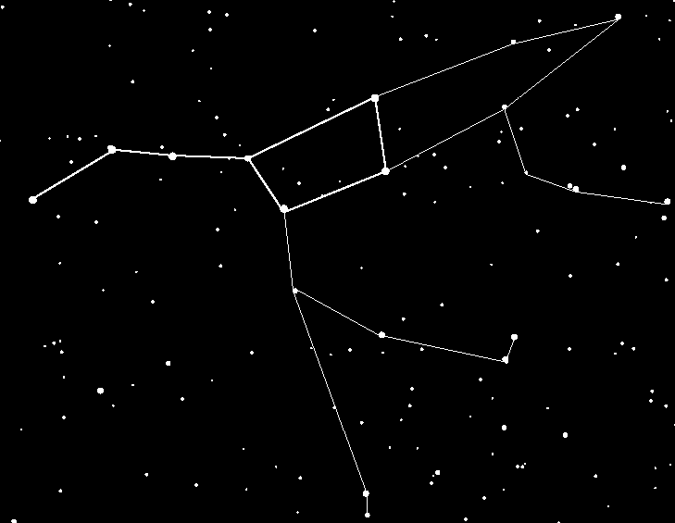

  - Light pollution – A glow around the atmosphere that prevents us from seeing faint stars
  - The North Star is not the brightest star
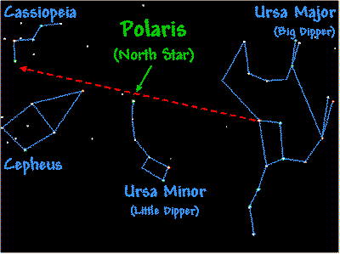
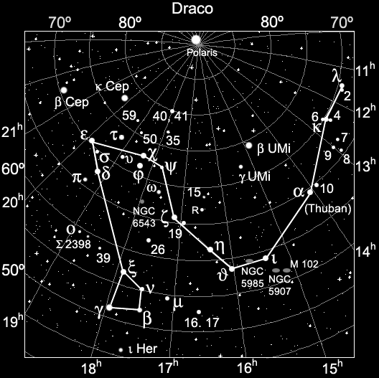

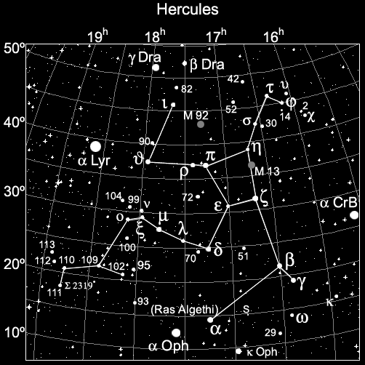

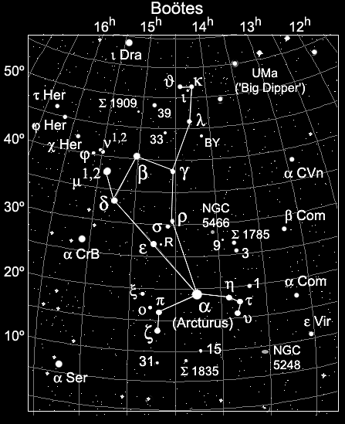

  - Cygnus the sawn
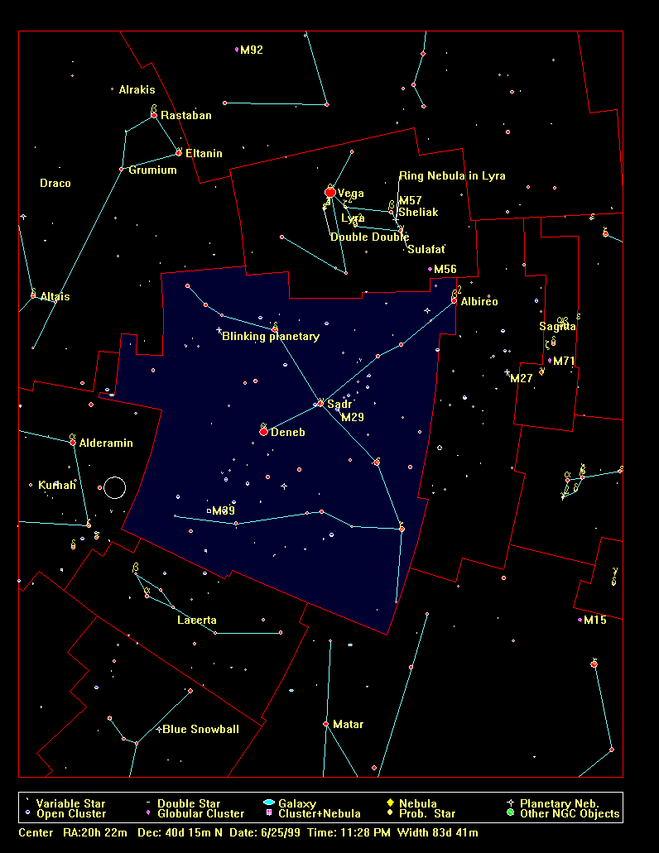

  - Northern Cross
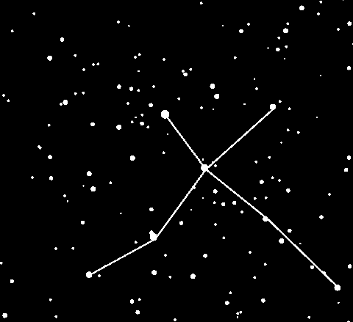

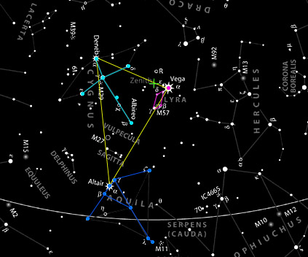

- Summer Constellations
  - Orion

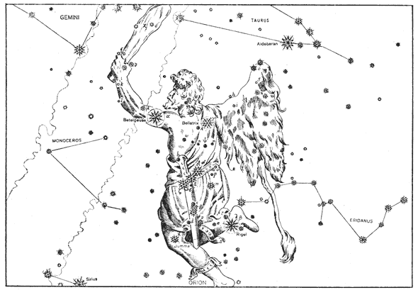
  - Taurus
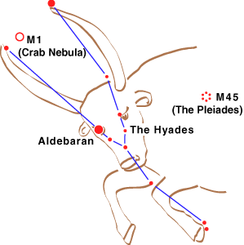

  - The Pleiades

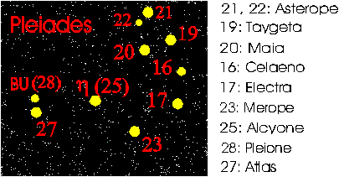
  - Canis Major – Sirius is the brightest star in the entire sky (besides the Sun)
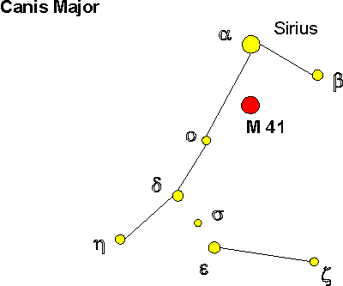

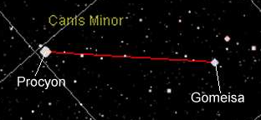
- Canis Minor

- Gemini – The Twins and Cancer – The Crab
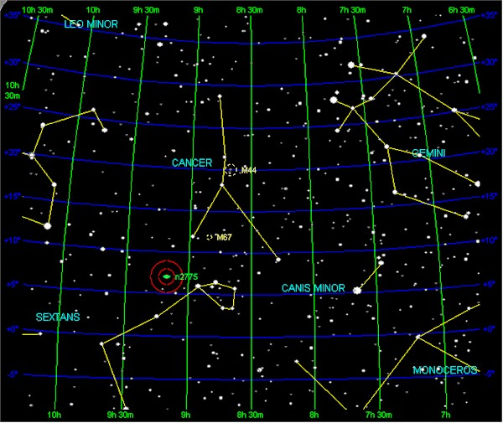

- Leo – The Lion
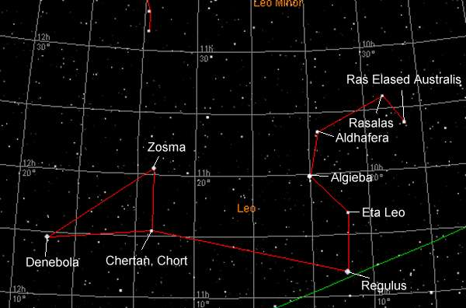

- Virgo – The Virgin

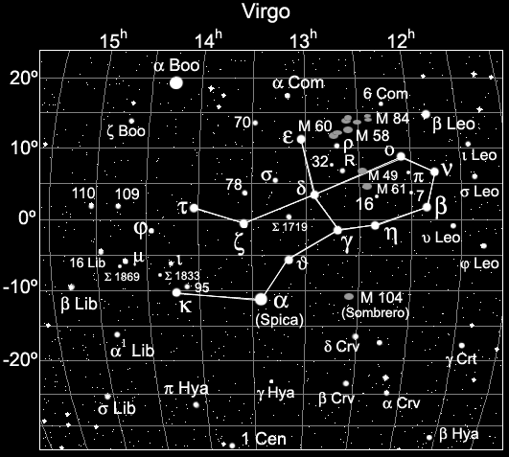
- The Ecliptic – The imaginary path followed by the Sun around the celestial sphere. Astrological signs (zodiac constellations) pass through these
- All of the Zodiac constellations are one month off

